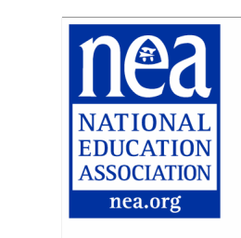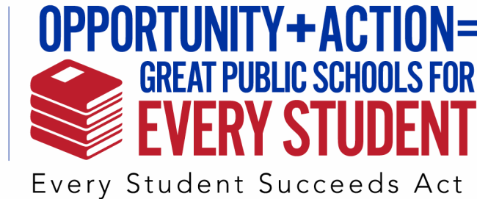

Sample Speech to Local School Board

With the signing into law of the Every Student Succeeds Act, called ESSA, we have an amazing
opportunity to move forward for and with our students. We no longer face the deeply flawed over-testing or the reduced local control of the No Child Left Behind era.

ESSA offers us a chance to be much more fair with our students, which will help us teach them more effectively and significantly boost their learning. For example, under ESSA, we can do two very important things we’ve been missing:
One, we can use multiple measures for student success, not just standardized test scores.
Two, we can devote more time to actual teaching and learning instead of giving tests.
ESSA recognizes that a “one-size-fits-all” approach has not worked, and never will.

This is a time of great change for our students, our schools, and our educators. Let’s not waste it. Full collaboration is going to be necessary in order for ESSA to be as effective as it’s meant to be.
We, the educators actually in the classrooms, need the opportunity to offer advice and input as our school system and schools implement this new law. More importantly, our students need that to happen. We know their names. We see firsthand what they need.

So, we in the _________ Education Association greatly look forward to having an active role in the changes and opportunities given all of us under ESSA, and we look forward to working with board members, administrators and other policymakers as we move forward.

Thank you very much.

Optional:
Earlier, we shared with you copies of a resolution supporting positive change under ESSA. We urge you to adopt it so we can move ahead in a clear and unified way.

